OPPORTUNITES UNVEILING MARKET INSIGHTS : ANALYSING SPENDING BEHAVIOUR AND IDENTIFYING FOR GROWTH:

**Project Description**

Wholesaling or distributing is the sale of goods  to retailer to [industrial](https://en.wikipedia.org/wiki/Manufacturing), commercial, [institutional](https://en.wikipedia.org/wiki/Institutional) or other professional businessman to other wholesalers (wholesale businesses) and related subordinated services.  Wholesaling is buying goods in bulk quantity, usually directly from the manufacturer or source, at a discounted rate. The retailer then sells the goods to the end consumer at a higher price making a profit.

The consumption and production of marketed food are spatially separated. Production is primarily in rural areas while consumption is mainly in urban areas.In today's highly competitive business landscape, gaining deep market insights is essential for businesses to thrive and grow. This project aims to analyze customer spending behavior and identify opportunities for growth by leveraging data analytics and data-driven decision-making.

The primary objective of this project is to understand customer spending patterns, preferences, and trends across various dimensions.. By conducting a comprehensive analysis, businesses can optimize their marketing strategies, improve product offerings, and enhance customer engagement to drive revenue growth.

**Technical Architecture:**

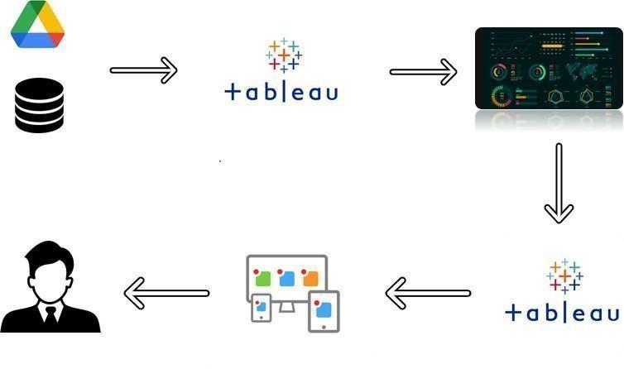

**DATA LITERACY** : Data literacy is the ability to derive meaningful information from data, just as literacy in general is the ability to derive information from the written word. The complexity of data analysis, especially in the context of big data, means that data literacy requires some knowledge of mathematics and statistics.

# **Insights & Analytics**

Translating consumer insights and big data into concrete initiatives that drive above-market growth.

A company’s ability to drive above-market growth hinges on the depth of its consumer insights and how well it translates those insights into effective action. Our area of work is made up of more than 130 dedicated insights and analytics experts and professionals—with more than 900 years of collective experience in 12 countries and 25 cities across the world—focused on helping our clients do exactly that.

To develop deep customer understanding, we employ a range of quantitative and qualitative marketing research approaches plus big data techniques that are both innovative and pragmatic. We’ve grouped our capabilities into two areas.

**Consumer & Shopper Insights:** [Insights](https://www.mckinsey.com/capabilities/growth-marketing-and-sales/how-we-help-clients/consumer-shopper-insights) into consumers can help companies spark innovation, uncover the most promising (though not always most intuitive) sources of growth, and develop or maintain successful products and brands. McKinsey’s qualitative and quantitative marketing research approaches, tools, and techniques help our clients discover why their customers behave as they do at every phase of their purchase decision journey, understand their customers’ experiences, and dig deeply into their best drivers of customer loyalty. By applying these insights, our clients can develop innovative and differentiated marketing strategies that include effective value propositions, segmentation, branding, product design, pricing, and customer experiences.

## **ADVANCED ANALYTICS :**

[McKinsey’s Consumer Marketing Analytics Center](https://www.mckinsey.com/capabilities/growth-marketing-and-sales/how-we-help-clients/cmac) (CMAC) accelerates the potential of big data by translating insights from advanced analytics into action across the marketing and consumer-facing organization. Using its global team of analytics professionals with deep expertise in all aspects of big data acquisition and interpretation, CMAC has acquired a track record of success identifying and applying best practices to create insights-driven organizations across a range of industries, including retail, consumer goods, banking, insurance, telecom, media, and healthcare.

## **What we do**

Our goal is to help our clients develop a set of practical and interlocking capabilities that reveal—and maximize the profitable use of—the data appropriate to their situation. We do this by:

* **Discovering insights by analyzing multiple data sources.** We identify and source both relevant internal and external data, and help upgrade the necessary IT infrastructure. We focus on speed to deliver consumer insights quickly, sometimes in as little as 10 days.
* **Designing programs based on the insights generated.** We work with leaders and frontline users to develop internal processes and incentives as well as a culture that uses insights for profitable decision making. We build prediction and optimization models, for example, to focus on the biggest drivers of value. These models balance complexity with ease of use. In setting up programs, our aim is to create an ongoing “insights factory.”
* **Delivering insights-driven growth for the short- and long-term.** We develop simple tools for the front line and provide training in how to use them to extract meaningful insights from complex data sets. Our state-of-the-art, ISO-certified data center in Atlanta provides IT and data-support infrastructure. Our teams are fluent in a wide range of crucial software languages.

## **How we help**

* **Customer-lifecycle management.** By using proprietary customer data and analytics, clients can acquire, develop, and retain high-value customers more profitably and effectively—and drive the necessary organizational changes from the C-suite through to the frontline.
* **Marketing return on investment.** Our tools track activities along the entire customer decision journey to bring transparency to marketing return on investment. By optimizing the effectiveness of marketing spend across the board, clients can free up 10 to 20 percent of their investment to reinvest for growth or take as bottom-line savings.
* **Pricing and promotions.** Our suite of proprietary methods, innovative research, analytic software solutions, and economic simulators for complex scenario analysis aid clients in pricing, promotions, and trade terms to optimize return on sales.
* **Assortment optimization.** Adopting an analytically driven approach to assortment optimization helps clients determine which items should be stocked where to maximize profit. Our approach has the flexibility to optimize at multiple levels, from department and category down to microspace.

- **EMAPTHY MAP:**

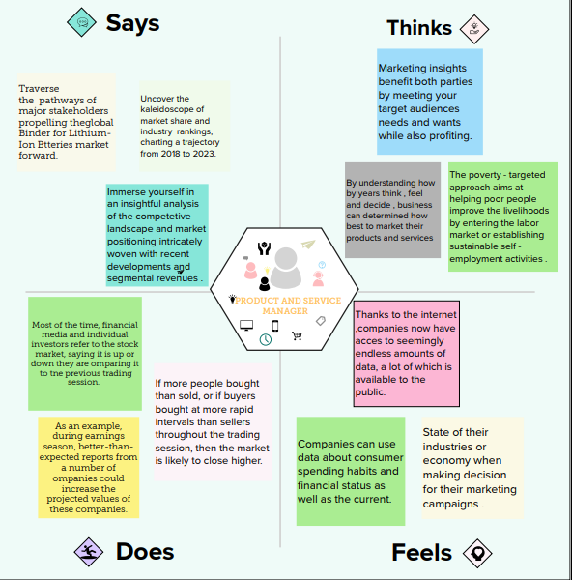

An empathy map is a tool used in design thinking to build an emotional representation of a user or the customer. It's a versatile activity that may be used to generate new product ideas as well as better understand existing ones.

**BRAINSTORM MAP:**

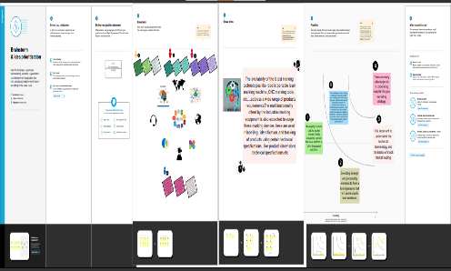Brainstorming is a way of generating ideas and organising your thinking on a topic. It can take shape as a simple list, an outline or a mind map. Once you have generated some ideas, you can evaluate and organise them, and narrow down your focus.  **BRAINSTORMING IN MARKETING**: Brainstorming in the process of searching for ideas by taking every thought – no matter how awkward it is – into consideration . Some will transform into marketing decision later , but the primary goal of this process is to go above and beyond the perceived “best practices .

## C:\Users\ragav\Pictures\Sheet 1.pngC:\Users\ragav\Pictures\Sheet 3.pngC:\Users\ragav\Pictures\Sheet 5.png

